# Additional Information

See the

C:\Custom Program Files\LaTeX\Processing Support\Notes\

directory for additional installation requirements.

# Adding a Custom Button

Open:

Options->Preferences->Advanced

Edit the WinEdt.btn file:

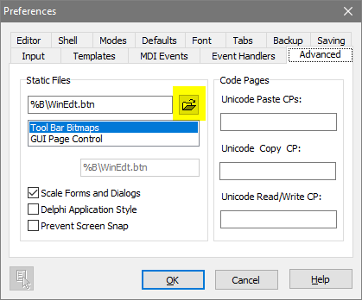

Add a line to the end of the file similar to:

204 %B\Bitmaps\Buttons\Command Prompt.bmp

205 %B\Bitmaps\Buttons\Recycle.bmp

206 %B\Bitmaps\Buttons\Recycle.bmp

207 %B\Bitmaps\Buttons\image.bmp

The number in that line will be the button number is the toolbar setup.

Use a bmp from one previously defined.

# Add a New Command

Enter the menu setup

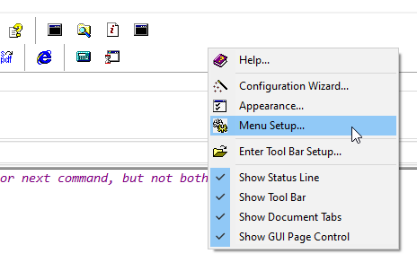

Double click an entry to open

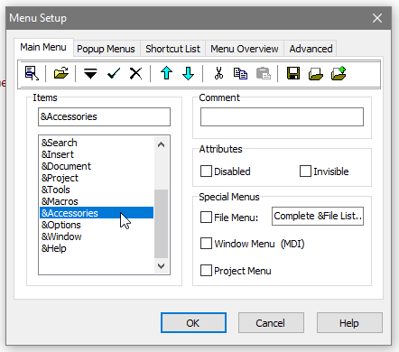

Commands:

Run('runmakedocument.bat "%N"','',0,0,'Make Document',1,1);

%P

Run('cleantempfiles.bat','',0,0,'Clean Up',1,1);

%P

Run('cleanalloutput.bat','',0,0,'Clean Up',1,1);

%P

Run('convert_all.bat','',0,0,'Make Images',1,1);

%P\Figures\Image Sources\

Set the button in “Images and Hint” to the one created in the previous section.

